CPSC 4240/6240 Discovery 2 50 points Name: Ashlyn Cooper
Instructions:
This homework is done individually, not in groups. You are allowed to use search engines, textbook/s, lecture notes, and any other sources you wish. But you are not allowed to copy-paste from Internet, or help others with their work, either by giving them hints or solutions.
You will take a number of screenshots. All screenshots should be clearly legible and illustrate without a doubt what you are doing. You can open them in an image editor of your choice and trim off the parts you do not need, just to make images smaller. Insert them when answering the question, do not submit them separately as image files. Since this is an editable word document, you can make space between the questions and type your answers and insert screenshots here. Please do not type in red, any other color is fine. I read everything you write, so if you just type in black, I will not miss your answer 😊
Grading and Points
Every question indicates how many points it is worth. 4000-level and 6000-level are graded differently, with points indicated as (x/y), where x is 4240 and y is 6240.
Exercises
- Figure out how to display GRUB on startup for a single-OS system. In multi-boot system it will be shown automatically. Research which grub variables you need to change to do this. (4/4)
On Ubuntu (my VM) in order to make GRUB appear on startup on a single-OS system, you need to press and hold the shift key if using BIOS) (if using UEFI, you press the escape key). In order to make a permanent change to make GRUB show up, the /etc/default/grub file needs to be changed. After making changes sudo update-grub needs to be run to apply the changes.
Here is the GRUB menu: 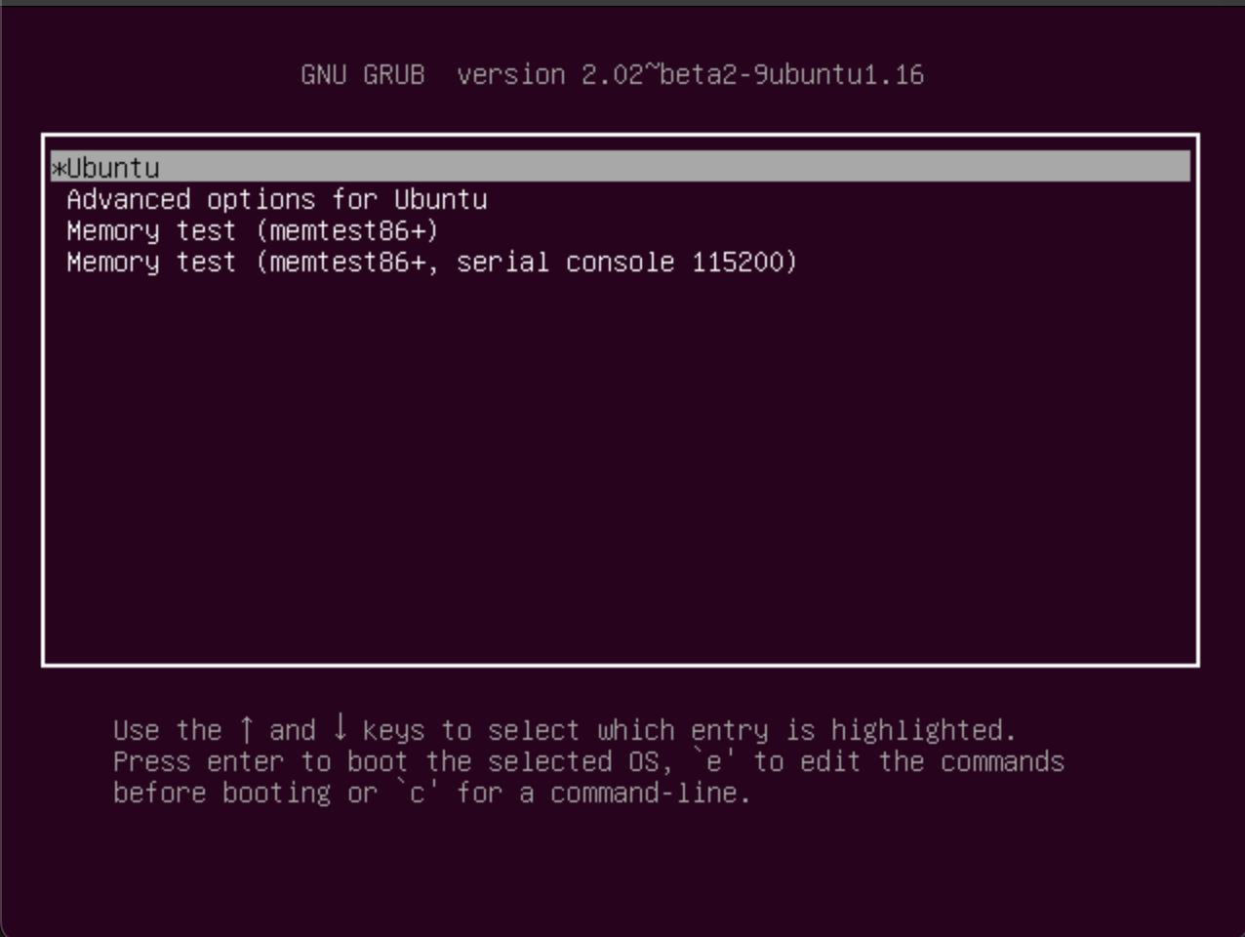
Here is the grub configuration file that needs to be changed to permanently have GRUB boot by addin a ‘#’ to the line GRUB_HIDDEN_TIMEOUT=0. 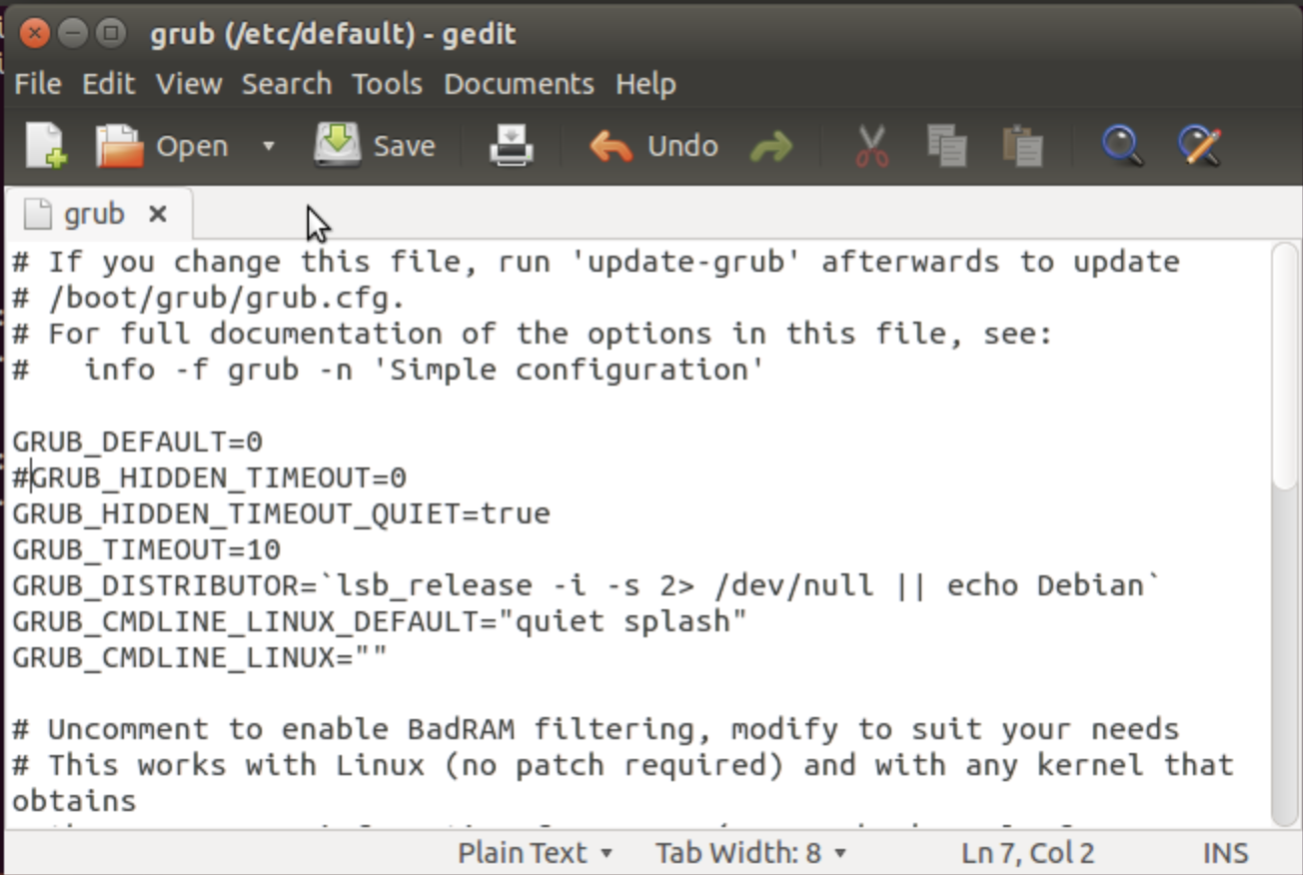

After changing the file, we run the sudo update-grub to save the changes. 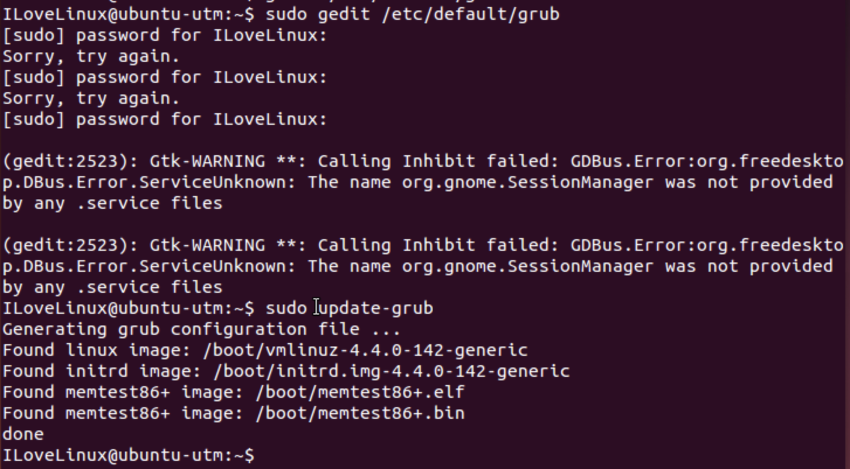
- Change background image for GRUB menu. There is more than one way to do this. Which way did you use? (4/3)
You can change the background image for GRUB menu either through the command line or by using the system file manager. The way that I chose was through the command line. To set the background image through the command line, you first open the grub.cfg file and then you change GRUB_BACKGROUND to equal the path to your desired image, after saving the file, you then run sudo update-grub.
Here is what the terminal looks like after running sudo update-grub showing that a background image was found:
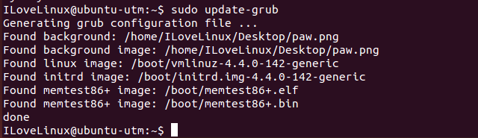
Here is the grub loading menu with the new image:
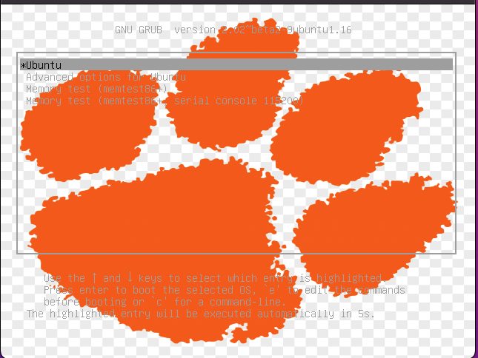
3. Explore /dev directory. It contains files associated with all phisical, virtual, and pseudo
devices. Notice that there is a number of loop devices and tty devices.
a. Explain what loop and tty devices are and why there are so many of them?
Loop devices are regular files or devices that are mounted as a file system. They can be thought of as “pseudo devices” due to the operating system kernel treating the contents as a block device. TTY is an abstract device in Linux that is a subsystem that allows for process management, line editing and session management at the kernel level. There are so many of these kinds of devices because they allow for many different controllers. Because these types of files serve as the link between the user and the device, there is a large number of them for the different consoles and ways the user can interact with the system.
b. Also, explain the difference between tty and pty devices.
Tty originally means “teletype” and pty originally means “pseudo-teletype.” A pty is a pseudotty and is a device entry that acts like a terminal to the process reading and writing there, but it is managed by something else. So instead of communicating directly to a “real” terminal, pty transfers input and output data to another program.
c. Now research what vcs, vcsu, and vcsa devices are and why so many of them. (18/16)
vcs is a device that corresponds to the tty device with the same number. In essence the vcs devices are scroll back buffers for the virtual terminals represented by tty devices. They are character devices for each of the virtual console terminals. There are so many vcs devices because there is a corresponding device for each tty device, which there is a lot of. Vcsu is a device that complements the vcs devices. It is a pseudo device that obtains screen text and they allow the reading of Unicode data from the screen. There are many vcsu devices due to the number of vcs devices. Vsca is a device that holds unsigned shorts that includes attribute about the screen including things like cursor position and screen dimension.
- Explore journald.conf file. What are the 4 Storage options and what does each option mean? Set the limit of how much hard drive space logs can use (4GB), and how much space should be left for other users to use (50GB). Set maximum file size to 3GB. Show a screenshot of your configuration file where you set these values. Please make sure all screenshots you use are large enough to clearly see what you are trying to show. You can trim it in the photo editor. (8/8)
The 4 storage options for the journald.conf file are volatile, persistent, auto, and none. If the option is volatile, the journal log data will only be stored in memory. If the option is persistent, the data will be stored on disk preferably, below the journal hierarchy /var/log/journal (which is created if needed) with a fallback to /run/log/journal during early boot and if the disk is not writable. If the option is auto, it is like persistent. However, the /var/log/journal is not created if needed so its existence controls where the log data goes. If the option is none, all storage is turned off and all logged data received will be dropped.
Unfortunately, my system does not have the journald.conf file (or at least I could not find it through any search or in any directory it should be in, so I cannot complete the second part of the question. It should be in the /etc/systemd directory, but it is not. 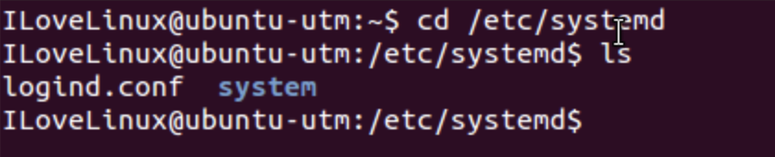
- Experiment with log rotation feature. Explain what you have tried, what you learned, and show a screenshot or two to illustrate your point. (8/7)
Log rotation is necessary because if logs were kept forever, they would eventually fill up the filesystem where /var/log resides. To prevent that fill up of the system, system administrators can use logrotate to clean up logs on a periodic basis. Logrotate will compress or rename the main log when a certain condition is met, so that when the next evet is recorded, it is recorded on an empty file. It will also remove “old” files and keep the most recent ones. The definition of “old” is decided by the system administrator as well as the frequency of log clean up.
I was able to find the logrotate configuration file in the /etc directory. 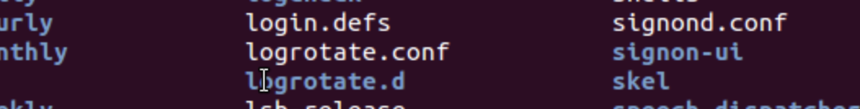
Going into the file I could see where I could edit the configuration to make the changes that I described above. You can change how many week’s worth of backlogs you want to keep, what the default syslog group is, and if you want your logs compressed. I learned that a system administrator can have a lot of control over the logging capabilities over their machine with the configuration settings in the file. 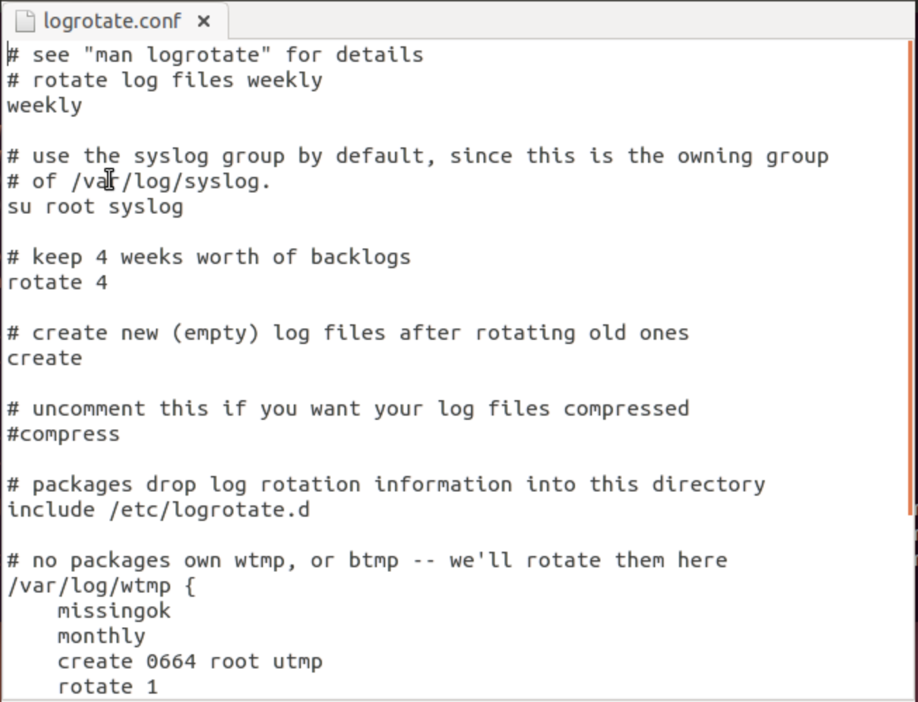
6. Linux filesystem contains many different file types, such as regular files, directories, and links that are indicated by -, d, or an l in the long file listing. There are two file types that you probably have not seen so far, they are called pipes (or named pipes) and sockets and contain letters p and s in front of the permissions bits in long listing format. Please do some research and explain what those pipes and sockets are, and what their function in the filesystem is. Then search directories and find two examples of each. Please attach screenshots. (8/6)
The socket files are a special file type that are like TCP/IP sockets. They allow inter-process communication that is protected by the filesystem’s access control. After using the find command to find what directories contained files that are of socket type, I honed in on one directory and found 4 socket files, including one called control and gpg. 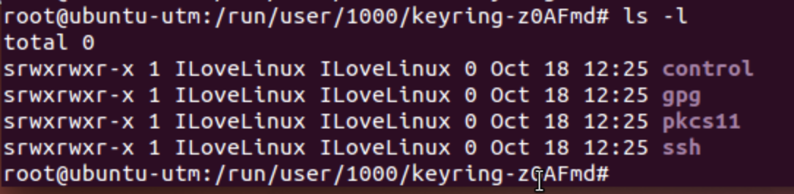
The pipes or named pipes act like sockets and they form a way for processes to communicate with each other without using the networking socket semantics. They connect the output of one process to the input of another. We can find pipes in the same way as with the sockets by we change the s flag to a p. Like finding the sockets, I used the same method to find pipe examples. In the /run/systemd/inhibit directory there are several pipes named from 1 to 6.ref. 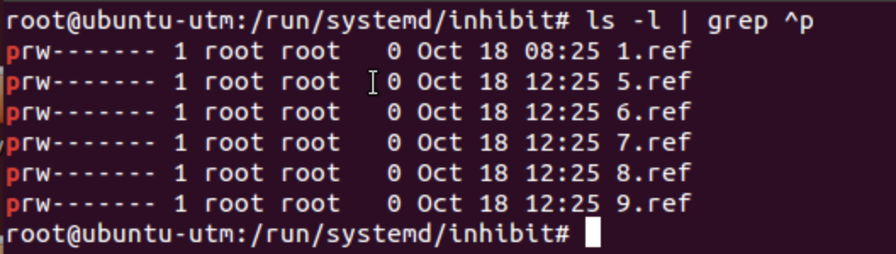

Graduate Students:
Linux kernel is open source. In this exercise you will search and download the latest kernel source code. What is the latest kernel version? Please provide the link where you have found the source code. What is the size of the file you have downloaded? Open the archive and inspect the code. What is the structure/layout of the kernel source code, what do directories contain? Open some files in an editor and try to figure out what the code does. Please describe your observations. Include some screenshots to illustrate your narrative. (0/6)
Undergraduate students can do this exercise for 5 extra credit points.
Graduate students can research how to compile the kernel (use virtual machine, in case something goes wrong). Document well with screenshots. 5 extra credit points.

